Teamworking Document Level 1

**Agree a definition of teamwork -** Teamwork is a group working together to achieve a common goal

**Develop a team agreement and all members sign this -**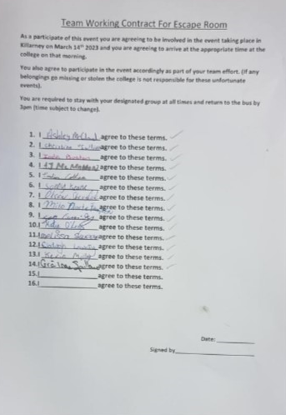

**Document strengths/skills required of team members and leaders-** Conflict Members must be able to resolve problems and disputes within the team in order for the team to be successful  
Respect is vital for any team to be successful. This entails listening to other people and respecting their opinions and ideas  
Members must be reliable within the team. This includes meeting deadlines and completing tasks in order to gain people's trust   
Team members have to be able to actively listen to other people's ideas and consider them in any potential plans  
Must be organised, Aware & a good listener  
Team members must be able to communicate ideas effectively within the team

**Agree roles, responsibilities, deadlines, authority levels for all team members at each stage –**Team Leader-Communication listening to everyone and make sure everyone feel included. Conflict management, collaborative skills, reliable  
Co-leader- Conflict management, Respectful, reliable, willing to compromise  
Minutes Taker- Take note of key meeting details, Information gathering skills, reliable

Photographer - Photograph different stages of the meeting, notes on whiteboard etc

**Perform a SWOT analysis on intra and inter team activity -** 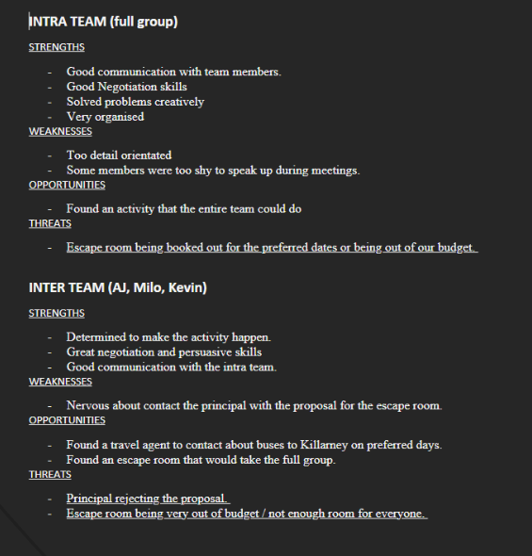

**Create a team vision, objectives, goals, action steps, responsibilities, deadlines-** 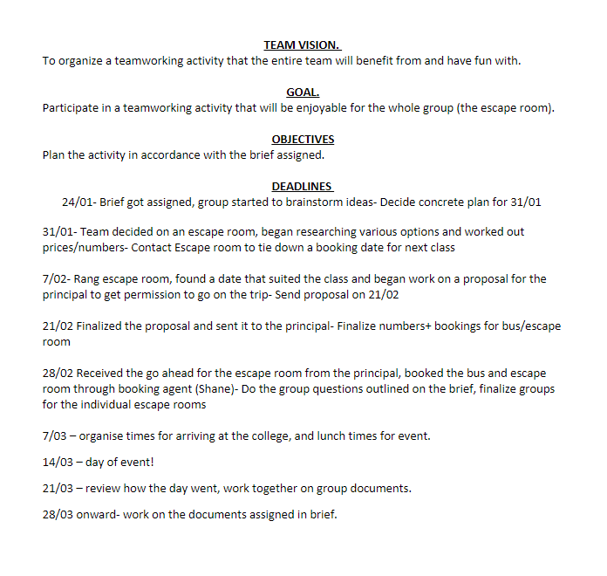

**Agree scheduling -**

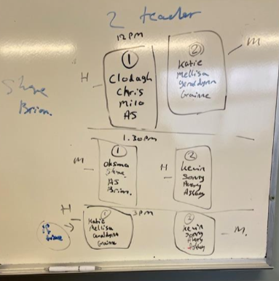

**Keep documentation for each stage of the process -** [Documentation for the Teamworking Process.docx](https://kerrycollegeoffurt-my.sharepoint.com/:w:/g/personal/clodaghlowery_student_kerrycollege_ie/EUgcCQLJur1OohApH3LrpX4BHXWBh19HXRKAGMeYnoGxwg?e=vabDlb) [Attendance.docx](https://kerrycollegeoffurt-my.sharepoint.com/personal/kevinmolloy_student_kerrycollege_ie/Documents/E%20Portfolio/Teamworking/Assignments/Assignment%203/Attendance.docx)

**Generate ideas -**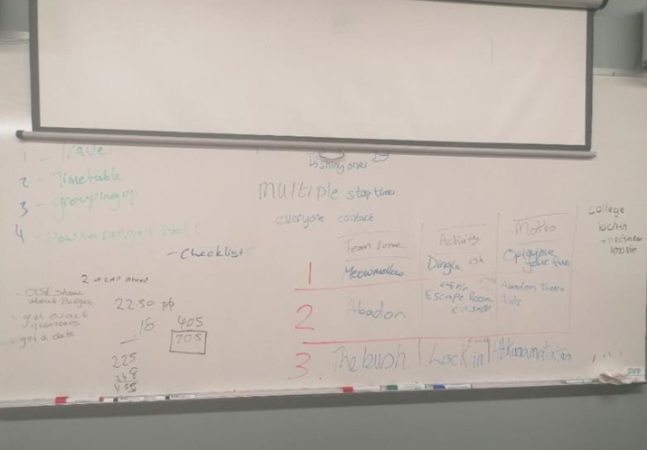

**List and apply the key skills required for effective problem solving, decision making, conflict resolution and negotiation -**Communication is a vital skill for teamworking and when used efficiently can solve any potential problems as well as helping to make informed and democratic decisions  
Being reliable and respectful are key parts of negotiation, especially if you are negotiating with a teammate with conflicting views  
Being able to manage conflict is a key part of resolving conflict. Respect and listening are also fundamental skills for conflict resolution, as to resolve conflict you need to respect your teammates and listen to their views

**Use written, verbal and non-verbal communication. Develop a team presentation with contribution from all team members -** [Teamworking Powerpoint.pptx](https://kerrycollegeoffurt-my.sharepoint.com/:p:/g/personal/sonnykeane_student_kerrycollege_ie/ESdrDJdifZZHho02GHElavMBAwIiPZX552YNhvtVux5glQ?e=VOKz2I)

**Perform a team assessment exercise to review how the team works together. Develop a checklist of supports needed for team well-being** 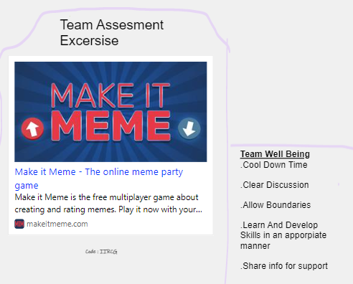

**Design feedback forms for self and peer feedback -** 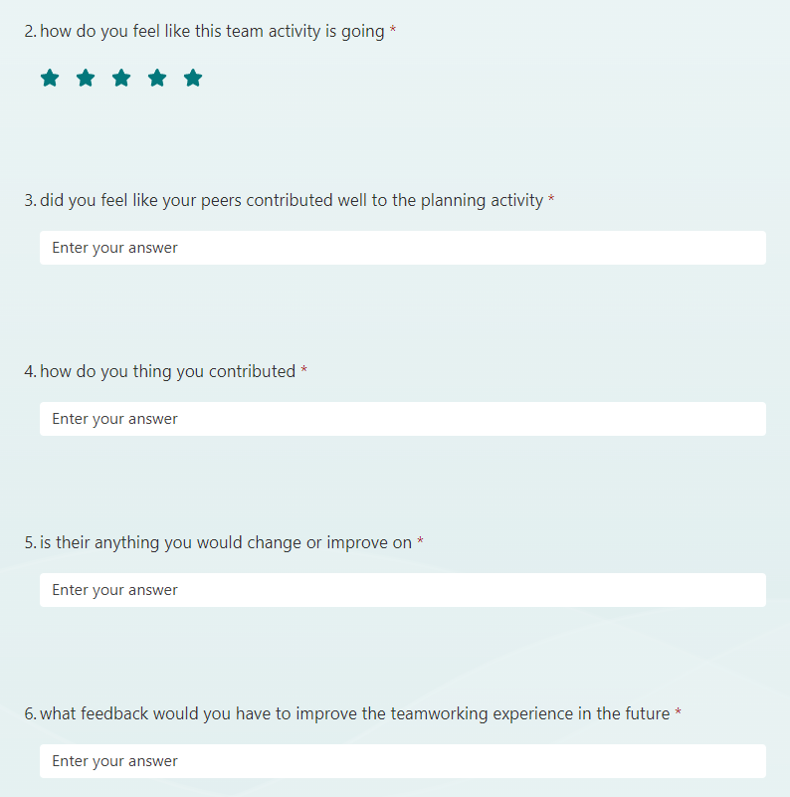

**Comment on the value of the team experience -** 